**Agile Tools**

Out of 7 lists of best scrum/agile tools, these are the most mentioned tools:

* *Jira*
* *Pivotal Tracker*
* *Target Process*
* *Vivify Scrum*
* *Wrike*
* *Monday.com*
* Active Collab
* nTask
* Nutcache
* Quickscrum
* ScrumDo
* ScrumWise
* Yodiz

**Jira**

General:

Requirement Engineering:

Via Pages, **a Product Requirements page** can be created. Entries include:

Success metrics: Goals and the corresponding success metric can be specified

Assumptions: assumptions about users, technical constraints etc.

Requirements: Requirements and their User Story, Importance and Notes can be created

Open Questions: Questions and their answers

**Decision Page**

Background: context for the decision

Relevant data: additional data that is important for the decision

Options Considered: Different Options can be documented with a description, the pros and cons and the estimated cost

Outcome: describe the outcome of the decision

Agile: Sprint, Backlog and Retrospective, tasks can have labels and subtasks

**Pivotal Tracker**

General: Focus on task management.

Requirement Engineering: User Stories are stored in Backlog, can be prioritized, Labels can be added

Agile: Tasks can be moved to current iteration

**Target Process**

* login must be requested, didn’t try

**Vivify scrum**

General: In Addition to task Management, there are tools for client management

Requirement Engineering: Items can have subitems and labels

Agile: Backlog and Sprint

**Wrike**

General: Project Management with Task Management, various display options, Gantt-Diagram

Requirement Engineering: tasks can have subtasks as well as predecessor and successor

Agile: Tasks can be in Progress, done, on hold, and cancelled. Project can have Phases (one of different Project Types to choose from)

**Monday.com**

General: Many different templates for different types of management, sprint planning board, feature backlog, sprint retrospective

Requirement Engineering: feature backlog, Tasks can have tags, impact

Agile: sprint tools, planning and retrospective tools

**General First Impression of Agile Tools**

The agile tools I tested out are mostly focussed on the management of tasks. There are features to organize them in a Backlog and Sprints or Iterations. Attributes like the assignee, the estimated effort, labels and the priority can be added to a task. Sometimes, tasks can be related to other tasks, for example the task can have a subtask. Often, there are functionalities for monitoring productivity and progress.

The options for requirement engineering mostly come in the form of tags or user stories. The only tool that offered options for requirements documentation is Jira. Here, a page can be created where user stories and requirements can be specified. A task can link such a page.

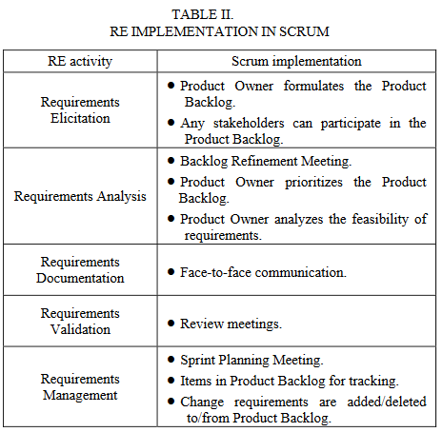

Requirements traceability refers to the ability to describe and follow the life of a requirement, in both a forwards and backwards direction [30]. One of the problems is that traceability is an important part in traditional software development but it is not a standard practice for the agile methods.

Method/ Criteria for evaluating Agile Tools in regards to Ethical Requirements Engineering

To Evaluate the agile tools in regards to working with ethical requirements, it is necessary to define some criteria. Since ethical deliberation can be categorised as a type of Requirements Engineering, it makes sense to look at the way RE can be integrated into the Agile Process. In “Requirements Engineering in Agile Software Development”, RE activities are mapped onto Scrum activities. This can be translated into a set of activities an agile tool should support in order to qualify for the ER process. In addition to these activities, the ethical deliberation requires traceability. “Requirements traceability refers to the ability to describe and follow the life of a requirement, in both a forwards and backwards direction”. In the ethical deliberation, traceability also means that the ethical requirements must have a logical derivation.

From the table we can gather that the requirements are stored in the Product Backlog. This means that a tool must have some form of a backlog to store the requirements. If a backlog is available, the way requirements can be modelled should be inspected. Is there an option to mark a backlog item as a requirement or can the backlog only contain tasks? In addition to that, the usability of the backlog in regards to requirements elicitation should be inspected. Are there helpful functions to assist the brainstorming of requirements or goals?

The requirements analysis includes prioritizing and refining the requirements and the resolution of conflicts. When refining a goal or requirement, the new requirements should be linked to their parent. This ensures that a requirement is traceable to its origin. Helpful for the traceability is also if the links can be visualised. This means that the tool has to support the prioritisation and refinement of requirements and linking requirements. Solving a conflict between requirements or goals is especially important in EDAP, because a core step is to solve ethical dilemmas. This requires the documentation of the decision made in the process and the argumentation that lead to it.

In the review meetings, the requirements are validated. This means that the system should fulfil a requirement. If the requirement is satisfied or not should be documented, which means that the backlog needs to support marking a requirement as satisfied or not.

During the sprint and the planning, requirements are added or deleted. Another part of requirements management is monitoring the requirements. This means that the backlog should support these actions.

Resulting Criteria:

* the tool provides an implementation of the product backlog or something similar
  + the backlog provides functionalities for:
    - adding and deleting items
    - editing items
    - prioritising items
    - differentiating between goals, requirements and tasks
    - linking items to other items
    - monitoring progress of items
    - marking items as fulfilled or unfulfilled
* the tool provides functionalities for documenting the conflict resolution for requirements

If a tool fulfils these criteria, it only means that RE could work on it, it doesn’t guarantee an easy and smooth workflow. That is why, in addition to these criteria, the tool should provide functionalities that make the RE and EDAP process easier and more intuitive, for example the option to visualise links between requirements or assisting questions that help in the requirement elicitation. For example, a tool could have the option to link requirements, but if the resulting graph can’t be visualised, tracing the requirements can get tedious and inefficient.